# Hands-on Lab 3: Entering and Formatting Data

Estimated time needed: 30 minutes

In this lab, first you will learn some of the viewing options in Excel, and then learn how to enter and edit data in cells. Then, you will learn how to move, copy, paste, and fill data, and how to format cells and cell data in a worksheet.

# Software Used in this Lab

The instruction videos in this course use the full Excel Desktop version as this has all the available product features, but for the hands-on labs we will be using the free 'Excel for the web' version as this is available to everyone.

Although you can use the Excel Desktop software if you have access to this version, it is recommended that you use Excel for the web for the hands-on labs as the lab instructions specifically refer to this version, and there are some small differences in the interface and available features.

# Dataset Used in this Lab

The first dataset used in this lab comes from the following source: [https://www.kaggle.com/sudalairajkumar/indian-startup-funding](https://www.kaggle.com/sudalairajkumar/indian-startup-funding?cm_mmc=Email_Newsletter-_-Developer_Ed%2BTech-_-WW_WW-_-SkillsNetwork-Courses-IBMDeveloperSkillsNetwork-DA0130EN-SkillsNetwork-20531059&cm_mmca1=000026UJ&cm_mmca2=10006555&cm_mmca3=M12345678&cvosrc=email.Newsletter.M12345678&cvo_campaign=000026UJ&cm_mmc=Email_Newsletter-_-Developer_Ed%2BTech-_-WW_WW-_-SkillsNetwork-Courses-IBMDeveloperSkillsNetwork-DA0130EN-SkillsNetwork-20531059&cm_mmca1=000026UJ&cm_mmca2=10006555&cm_mmca3=M12345678&cvosrc=email.Newsletter.M12345678&cvo_campaign=000026UJ) under a [CC0: Public Domain license](https://creativecommons.org/publicdomain/zero/1.0?cm_mmc=Email_Newsletter-_-Developer_Ed%2BTech-_-WW_WW-_-SkillsNetwork-Courses-IBMDeveloperSkillsNetwork-DA0130EN-SkillsNetwork-20531059&cm_mmca1=000026UJ&cm_mmca2=10006555&cm_mmca3=M12345678&cvosrc=email.Newsletter.M12345678&cvo_campaign=000026UJ). Acknowledgement and thanks also goes to [https://trak.in](https://trak.in/?cm_mmc=Email_Newsletter-_-Developer_Ed%2BTech-_-WW_WW-_-SkillsNetwork-Courses-IBMDeveloperSkillsNetwork-DA0130EN-SkillsNetwork-20531059&cm_mmca1=000026UJ&cm_mmca2=10006555&cm_mmca3=M12345678&cvosrc=email.Newsletter.M12345678&cvo_campaign=000026UJ&cm_mmc=Email_Newsletter-_-Developer_Ed%2BTech-_-WW_WW-_-SkillsNetwork-Courses-IBMDeveloperSkillsNetwork-DA0130EN-SkillsNetwork-20531059&cm_mmca1=000026UJ&cm_mmca2=10006555&cm_mmca3=M12345678&cvosrc=email.Newsletter.M12345678&cvo_campaign=000026UJ&cm_mmc=Email_Newsletter-_-Developer_Ed%2BTech-_-WW_WW-_-SkillsNetwork-Courses-IBMDeveloperSkillsNetwork-DA0130EN-SkillsNetwork-20531059&cm_mmca1=000026UJ&cm_mmca2=10006555&cm_mmca3=M12345678&cvosrc=email.Newsletter.M12345678&cvo_campaign=000026UJ) who were generous enough to share the data publicly for free.

We are using a modified subset of that dataset for the lab, so to follow the lab instructions successfully please use the dataset provided with the lab, rather than the dataset from the original source.

The second dataset used in this lab is an internal dataset.

# Objectives

After completing this lab, you will be able to:

* Use viewing options, and enter and edit data
* Copy and fill data, and format cells and data

# Exercise 1: Viewing, Entering and Editing Data

In this exercise, you will learn some of the viewing options in Excel, how to enter and edit data in cells.

## Task A: Viewing Data

1. Download the file [indian_startup_funding_Lab3.xlsx](https://cf-courses-data.s3.us.cloud-object-storage.appdomain.cloud/IBMDeveloperSkillsNetwork-DA0130EN-SkillsNetwork/Hands-on%20Labs/Lab%203%20-%20Entering%20and%20Formatting%20Data/indian_startup_funding_Lab3.xlsx). Upload and open it using Excel for the web.
2. Select F20:H26 (if required, use the vertical and horizontal scroll bars to bring the selected cell range area to the center of the screen). Hold CTRL and + to zoom in closer to the specific area of the data. Then hold CTRL and - to zoom the worksheet back out to its original size. (Note: Zoom to Selection which is found under the View tab of Excel Desktop, is not available for Excel for the web)
3. On the ribbon, click View, Freeze Panes, Freeze Top Row. Now you have headings in your columns like a header row, which will remain static on screen while you move down the worksheet. Next, click Unfreeze Panes, and click Freeze First Column. The *Sr No* column will remain static on the screen while you move right across the worksheet. Lastly, click Unfreeze Panes to end this step.  
   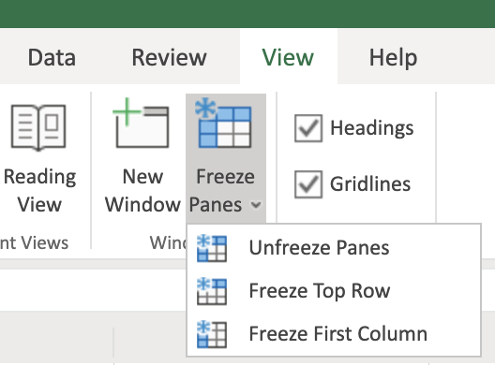
4. To freeze both the top row and the first column at the same time, select cell B2 and click View, Freeze Panes, Freeze Panes.  
   
5. You can open multiple workbooks in multiple browser tabs in Excel for the web, and to switch between them, you just click each browser tab. (In Excel Desktop you have to click the View tab, then click Switch Windows)

## Task B: Entering Data

1. Download the file [Personal_Monthly_Expenditure_Lab3.xlsx](https://cf-courses-data.s3.us.cloud-object-storage.appdomain.cloud/IBMDeveloperSkillsNetwork-DA0130EN-SkillsNetwork/Hands-on%20Labs/Lab%203%20-%20Entering%20and%20Formatting%20Data/Personal_Monthly_Expenditure_Lab3.xlsx). Upload and open it using Excel for the web. Go to the Expense - 2018 worksheet.
2. In cell A1, type Month and press Tab. Then type Housing and press Tab, type Food & Dining, and press Tab, type Personal, and press Tab, type Auto & Transport, then press Tab, type Health & Fitness, then press Tab. You are now done with the header row.
3. To enter some data as rows in column A, in A2, type Jan and press Enter. Then type Feb, and press Enter, type Mar, and press Enter, type Apr, and press Enter.
4. To add another column between the Housing and Food & Dining, select column C, then right-click column C, and choose Insert Columns. In the top row header cell C1, type Bills & Utilities.  
   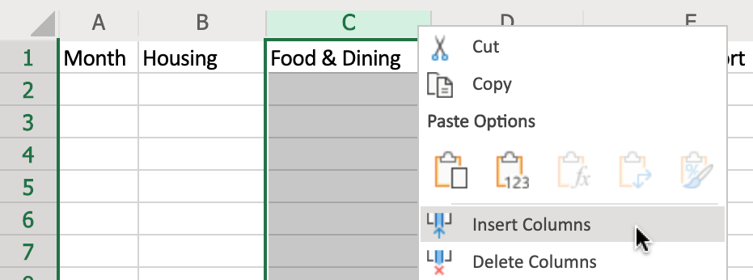
5. Select columns A to G, then double-click the divider between A and B to adjust the column widths.  
   

## Task C: Editing Data

1. Select cell C1 and press Backspace to clear the contents. Then type Bills.
2. Click Undo to undo the change.  
   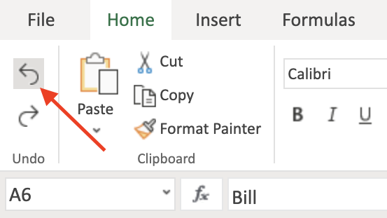

# Exercise 2: Copying, Filling, and Formatting Cells and Data

In this exercise, you will learn how to move, copy, paste, and fill data, and how to format cells and cell data in a worksheet.

## Task A: Copying and Filling Data

1. Select A2:A5. Hover over the edge of the selected cells to get the Move pointer and then drag the selection to move the selected cells to B6. Click Undo.  
   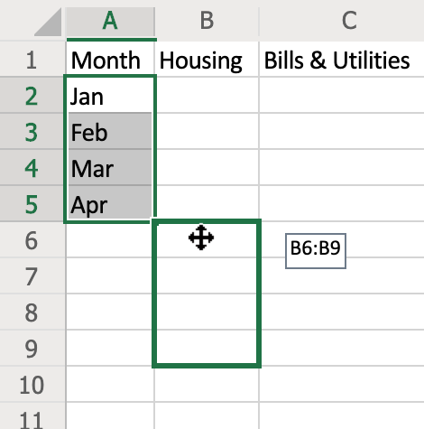
2. Select cell A5. Hover over the bottom right corner of cell A5 to get the + (Fill Handle) symbol, then drag to A13.  
   
3. On the Expense - 2018 sheet, select A1:G13 and press CTRL+C. Then on the Expense - 2019 sheet, select cell A1 and press CTRL+V.
4. Select cell A1 and press CTRL+A to select the whole datasheet. On the Home tab, in the Cells group, click the drop-down arrow under Format, and click Auto-Fit Column Width.  
   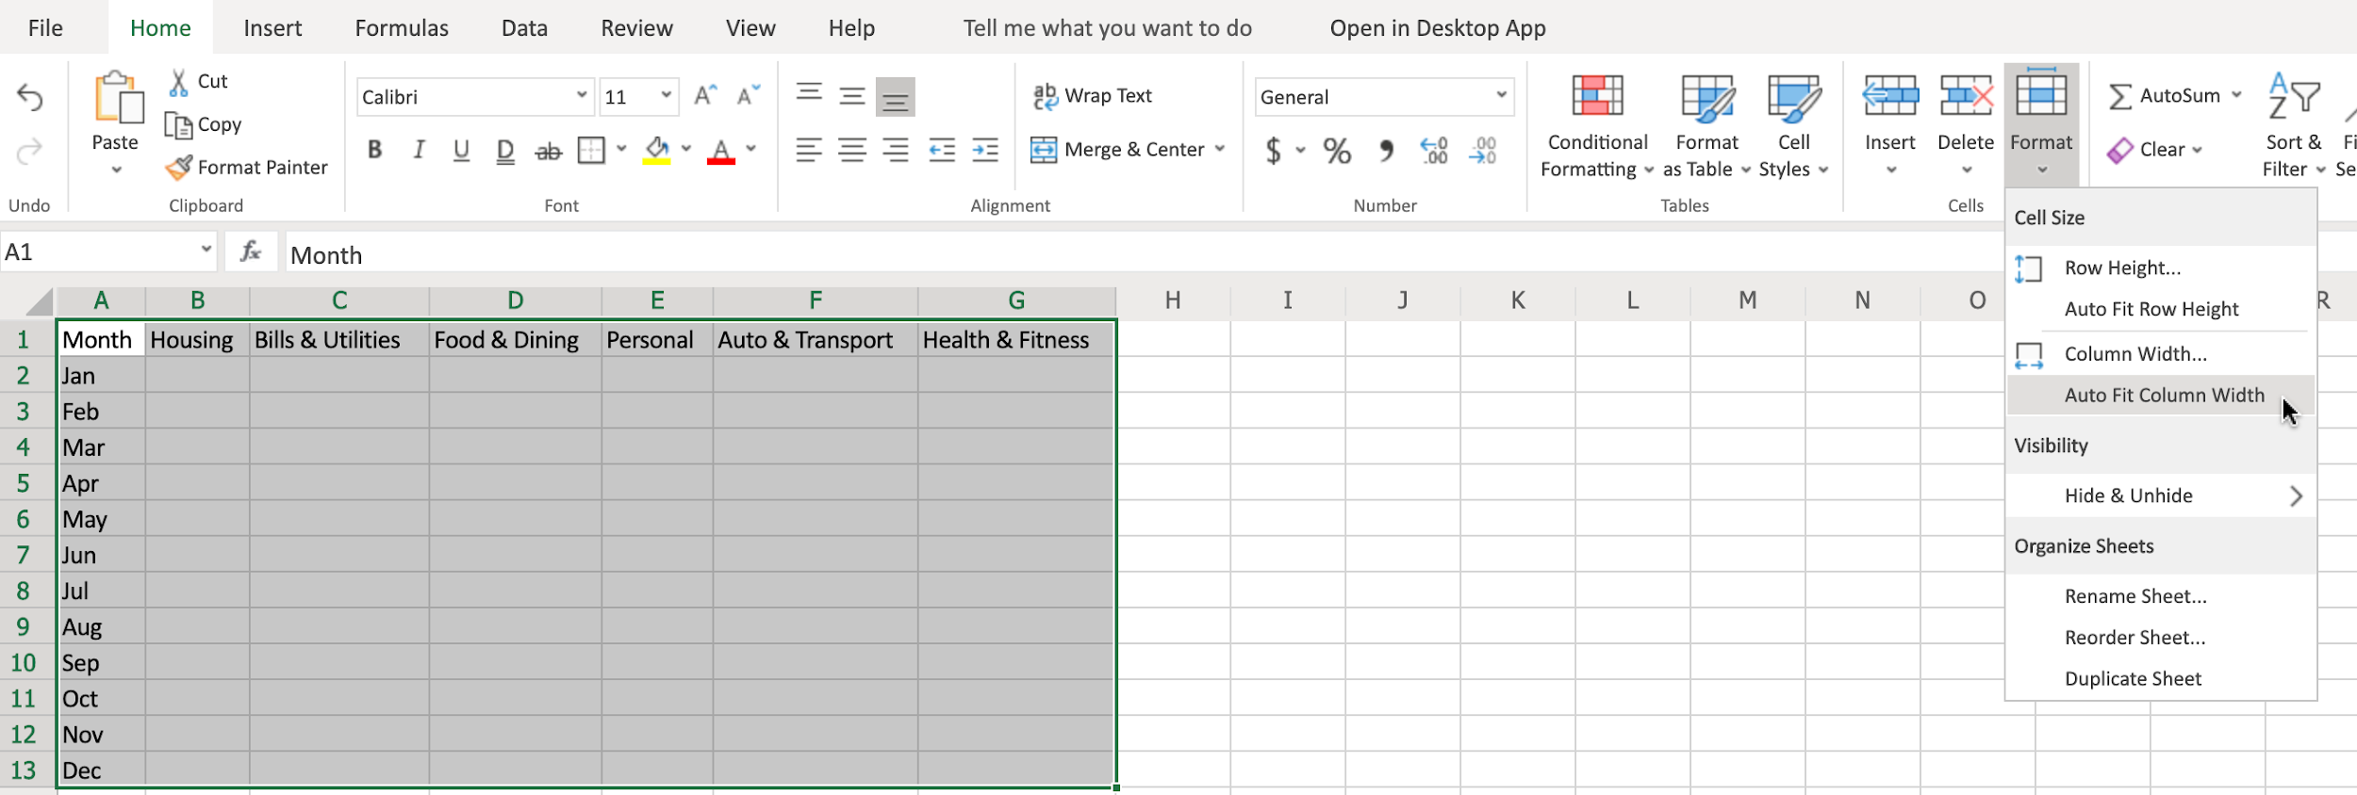

## Task B: Formatting Cells and Data

1. Formatting Cells:
   * a. Select A1:G13. On the Home, in the Tables group, click Format as Table, and choose a table style from the list. In the pop-up dialog box, ensure that the option My table has headers, is checked and then click OK.  
     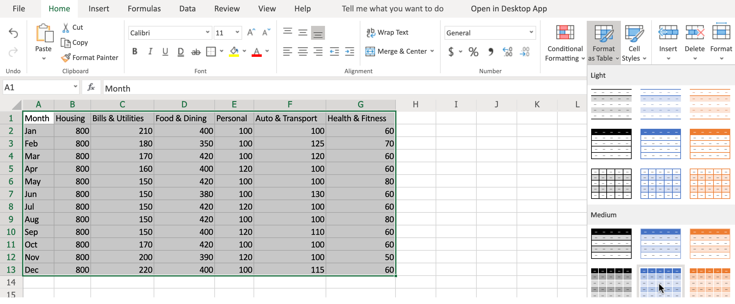
   * b. Select A2:A13. In the Font group click Italic. In the font size box, select 10. In the font style drop-down box, select Arial.
2. Formatting Cell Data:
   * a. Select column B, and use SHIFT+right arrow to select across to include column G. On the Home tab, in the Number group, click the Number Format drop-down list and choose Currency.
   * b. Select columns B to G again. On the Home tab, in the Number group, click Decrease Decimal once.
   * c. Select columns B to G again. On the Home tab, in the Number group, click the Accounting Number Format ($) drop-down list, and select £ English (United Kingdom).  
     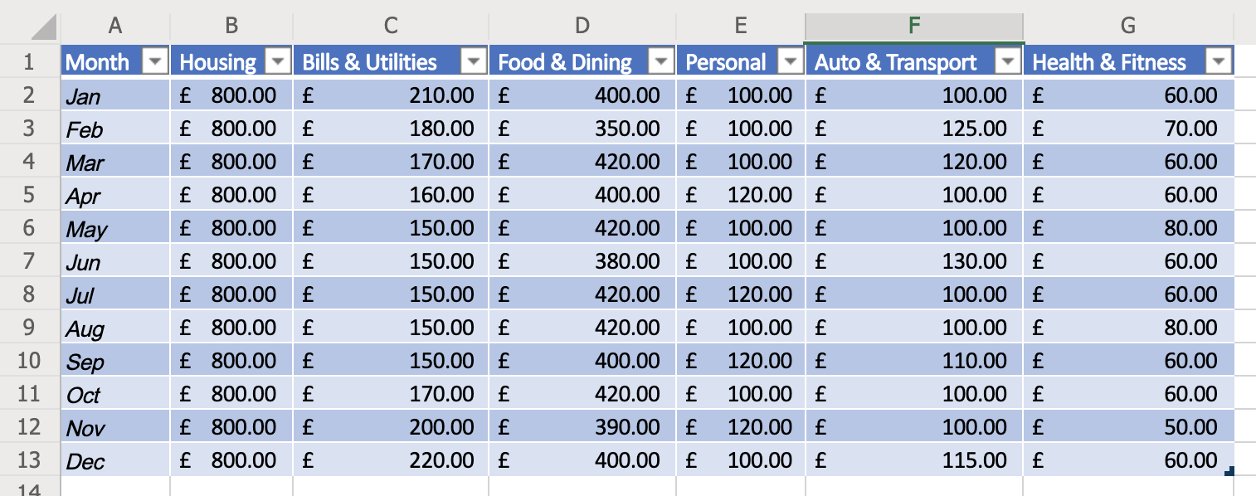

### Congratulations! You have completed Lab 3, and you are ready for the next topic.